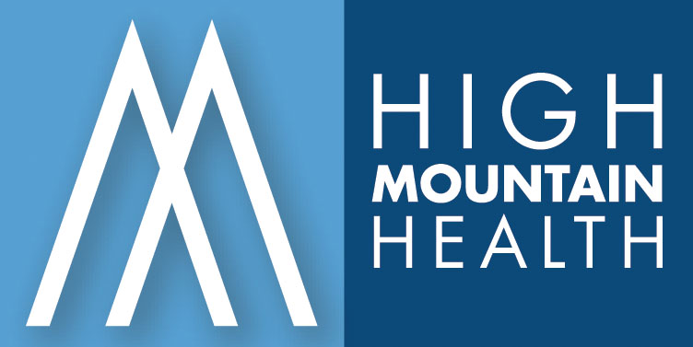

News Release From High Mountain Health

For Immediate Release

Contact: Nancy Ciccolella Bill Carlos
High Mountain Health Avow Communications
Practice Administrator Public Relations 973.305.8300 908.499.7862

HIGH MOUNTAIN HEALTH ADDS TWO NEW PARTNERS

TO THEIR EXPANDING NORTH JERSEY MEDICAL GROUP

Wayne, NJ – September 17, 2008 – The High Mountain Health medical group
recently promoted two of its staff physicians, Louis F. Perdomo, M.D., and Robert S. Dela Gente, D.O, as new partners in the 10-year-old medical team.

Dr Perdomo and Dr Dela Gente joined the medical staff of High Mountain Health in 2004 and 2005 respectively.

“We are very pleased to welcome Drs. Perdomo and Dela Gente as our new partners. This will benefit High Mountain Health patients and the community overall with the knowledge and years of experience they contribute to the High Mountain Health team,” said Dr. David V. Rasa, President of High Mountain Health, P.A.

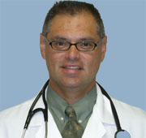
Dr. Perdomo earned his medical degree in 1988 from the San Pedro de Macoris Medical School in the Dominican Republic. He completed his Residency at the University of Medicine and Dentistry (UMDNJ) in Newark, NJ. He is board certified by the American Academy of Family Physicians and is a Diplomate of the National Board of Medical Examiners.

Dr. Perdomo is licensed to practice medicine in the states of New Jersey, New York and Connecticut. A resident of Bergen County, he is married and the father of two daughters and one son.
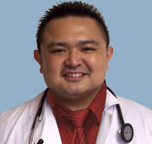
Dr. Dela Gente earned his medical degree in 2002 from the Western University of Health Sciences/COMP in Pomona, California. He completed his Residency at the University of Medicine and Dentistry (UMDNJ)/Christ Hospital in Jersey City.

(MORE)
High Mountain Health
Page 2

He is board certified by the American College of Osteopathic Family Physicians and is a Diplomate of the National Board of Osteopathic Medical Examiners. Also a resident of Bergen County, Dr. Dela Gente is married and the father of two daughters.

High Mountain Health now has seven (7) total partners. In addition to Dr. Rasa, the other partners in the practice are Dr.Charles Whang, Dr. Peter Carrazzone, Dr. George Guariglia and Dr. Antoinette DeIngeniis-DePasquale.

High Mountain Health takes healthcare to the next level by seeing patients 364 days a year in locations throughout Bergen and Passaic counties at:
- 468 Parish Drive, Wayne
- 535 High Mountain Road, North Haledon
- 19 Yawpo Road, Oakland, and
- 83 Long Hill Road, Little Falls

The medical group was founded in 1998 by Drs. Rasa, Carrazzone and Whang. It provides state-of-the-art techniques in diagnostic and interventional medicine coupled with a personal approach for the patient and their families. High Mountain Health’s services include Family Medicine, Women’s Health, Radiology, Physical Therapy and Sports Medicine and Cosmetic Services.

(End)

